

**Submitted By: Guided By:**

**Yashwant Tripathi Mr. Udai Nag**

**Roll No. (HOD Computer)**

**12th Science**

**Submitted To:**

**All India Senior Secondary Certified Examination**

**SESSION: 2015-16**

**This is to certify that Yashwant Tripathi, student of Class XII (Science) has satisfactorily carried out the project on**

**“School Management System”**

**under my personal guidance and supervision. All works related to the project was done by the candidate himself.**

**This report is in order of the task performed by him and I am satisfied by his work. His sincere efforts and persuasion could get this project completed.**

**Mrs. Smita Harwalkar Mr.Udai Nag**

**Principal HOD, Computer**

**Aditya Birla Public School Aditya Birla Public School**

**Completing this project was a difficult task for me until and unless the follow people helped me.**

**Therefore I would like to put forward my gratitude towards my subject teacher, Mr. Udai Nag who always extended helping hand when required.**

**At last but not the least my parents and my friend for their spiritual support.**

**Yashwant Tripathi**

Hardware’s required:

* RAM=1GB
* Internal Memory = 1GB (min)

Software’s used:

* Front End Application=Java NetBeans IDE
* Backend Application=MySQL

**This project is about School Management System. This**

**software helps you to record school data**

**and maintain it in proper way.**

**By using this application you can keep a record of data related to students, & teachers. You can add new records, update the record or you may delete the record.**

**Using this application you can find out about fees of the student. You can update the record time to time.**

* Table Student:

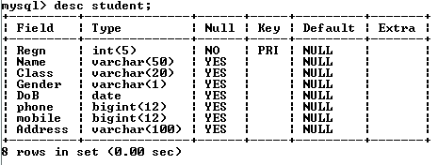

* Table Teacher:

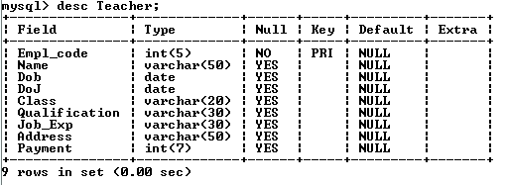

* Table Fees:

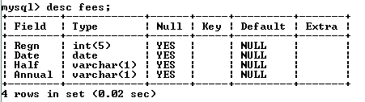

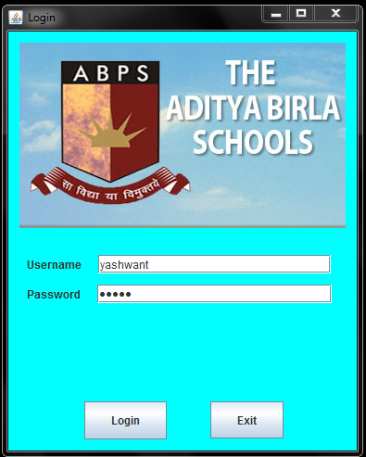

Coding:

*import java.awt.Color;*

*import javax.swing.JOptionPane;*

*private void loginActionPerformed(java.awt.event.ActionEvent evt) {*

String txtUname=Uname.getText();

String txtPwd=new String(pwd.getPassword());

if(txtUname.equals("yashwant"))

{

if(txtPwd.equals("admin"))

{

JOptionPane.showMessageDialog(null, "Welcome to ABPS");

MainPage m=new MainPage();

m.setVisible(true);

this.setVisible(false);

} else

{

wrong.setText("Invalid Password. Try Again");

}

}

else {

JOptionPane.showMessageDialog(null,"Invalid Username");

}

}

*private void exitActionPerformed(java.awt.event.ActionEvent evt) {*

System.exit(0);

}

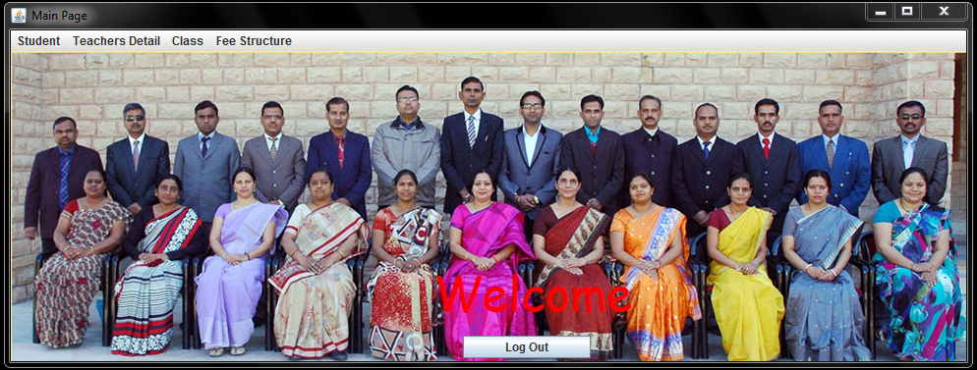

Coding:

*public class MainPage extends javax.swing.JFrame {*

String Grade;

*public MainPage() {*

initComponents();

}

*private void S_AddActionPerformed(java.awt.event.ActionEvent evt) {*

Student_info m=new Student_info();

m.setVisible(true);

this.dispose();

}

*private void S_UpdateActionPerformed(java.awt.event.ActionEvent evt) {*

Student_update m=new Student_update();

m.setVisible(true);

this.dispose();

}

*private void S_SearchActionPerformed(java.awt.event.ActionEvent evt) {*

student_sear m=new student_sear();

m.setVisible(true);

this.dispose();

}

*private void S_DelActionPerformed(java.awt.event.ActionEvent evt) {*

Student_delete m=new Student_delete();

m.setVisible(true);

this.dispose();

}

*private void T_AddActionPerformed(java.awt.event.ActionEvent evt) {*

Teacher_info m=new Teacher_info();

m.setVisible(true);

this.dispose();

}

*private void T_UpdateActionPerformed(java.awt.event.ActionEvent evt) {*

Teacher_update m=new Teacher_update();

m.setVisible(true);

this.dispose();

}

*private void T_SearchActionPerformed(java.awt.event.ActionEvent evt) {*

teacher_search m=new teacher_search();

m.setVisible(true);

this.dispose();

}

*private void T_DelActionPerformed(java.awt.event.ActionEvent evt) {*

teacher_delete m=new teacher_delete();

m.setVisible(true);

this.dispose();

}

*private void LKGActionPerformed(java.awt.event.ActionEvent evt) {*

Grade=LKG.getText();

NewJFrame m=new NewJFrame();

m.Grade=Grade;

m.setVisible(true);

this.dispose();

}

*private void UKGActionPerformed(java.awt.event.ActionEvent evt) {*

Grade=UKG.getText();

NewJFrame m=new NewJFrame();

m.setVisible(true);

m.Grade=Grade;

this.dispose();

}

*private void FirstActionPerformed(java.awt.event.ActionEvent evt) {*

Grade=First.getText();

NewJFrame m=new NewJFrame();

m.Grade=Grade;

m.setVisible(true);

this.dispose();

}

*private void SecondActionPerformed(java.awt.event.ActionEvent evt) {*

Grade=Second.getText();

NewJFrame m=new NewJFrame();

m.Grade=Grade;

m.setVisible(true);

this.dispose();

}

*private void ThirdActionPerformed(java.awt.event.ActionEvent evt) {*

Grade=Third.getText();

NewJFrame m=new NewJFrame();

m.Grade=Grade;

m.setVisible(true);

this.dispose();

}

*private void FourthActionPerformed(java.awt.event.ActionEvent evt) {*

Grade=Fourth.getText();

NewJFrame m=new NewJFrame();

m.Grade=Grade;

m.setVisible(true);

this.dispose();

}

*private void FifthActionPerformed(java.awt.event.ActionEvent evt) {*

Grade=Fifth.getText();

NewJFrame m=new NewJFrame();

m.Grade=Grade;

m.setVisible(true);

this.dispose();

}

*private void SixthActionPerformed(java.awt.event.ActionEvent evt) {*

Grade=Sixth.getText();

NewJFrame m=new NewJFrame();

m.Grade=Grade;

m.setVisible(true);

this.dispose();

}

*private void SeventhActionPerformed(java.awt.event.ActionEvent evt) {*

Grade=Seventh.getText();

NewJFrame m=new NewJFrame();

m.Grade=Grade;

m.setVisible(true);

this.dispose();

}

*private void EighthActionPerformed(java.awt.event.ActionEvent evt) {*

Grade=Eighth.getText();

NewJFrame m=new NewJFrame();

m.Grade=Grade;

m.setVisible(true);

this.dispose();

}

*private void NinethActionPerformed(java.awt.event.ActionEvent evt) {*

Grade=Nineth.getText();

NewJFrame m=new NewJFrame();

m.Grade=Grade;

m.setVisible(true);

this.dispose();

}

*private void TenthActionPerformed(java.awt.event.ActionEvent evt) {*

Grade=Tenth.getText();

NewJFrame m=new NewJFrame();

m.Grade=Grade;

m.setVisible(true);

this.dispose()

;

}

*private void Eleven_SActionPerformed(java.awt.event.ActionEvent evt) {*

Grade=Eleven_S.getText();

NewJFrame m=new NewJFrame();

m.Grade=Grade;

m.setVisible(true);

this.dispose();

}

*private void Eleven_CActionPerformed(java.awt.event.ActionEvent evt) {*

Grade=Eleven_C.getText();

NewJFrame m=new NewJFrame();

m.Grade=Grade;

m.setVisible(true);

this.dispose();

}

*private void Twelfth_SActionPerformed(java.awt.event.ActionEvent evt) {*

Grade=Twelfth_S.getText();

NewJFrame m=new NewJFrame();

m.Grade=Grade;

m.setVisible(true);

this.dispose();

}

*private void Twelfth_CActionPerformed(java.awt.event.ActionEvent evt) {*

Grade=Twelfth_C.getText();

NewJFrame m=new NewJFrame();

m.Grade=Grade;

m.setVisible(true);

this.dispose();

}

*private void F_DepositedActionPerformed(java.awt.event.ActionEvent evt) {*

feedepo m=new feedepo();

m.setVisible(true);

this.dispose();

}

*private void F_UpdateActionPerformed(java.awt.event.ActionEvent evt) {*

Deposited m=new Deposited();

m.setVisible(true);

this.dispose();

}

*private void F_RemainingActionPerformed(java.awt.event.ActionEvent evt) {*

feeremain m =new feeremain();

m.setVisible(true);

this.dispose();

}

*private void logoutActionPerformed(java.awt.event.ActionEvent evt) {*

login1 m=new login1();

m.setVisible(true);

this.dispose();

}

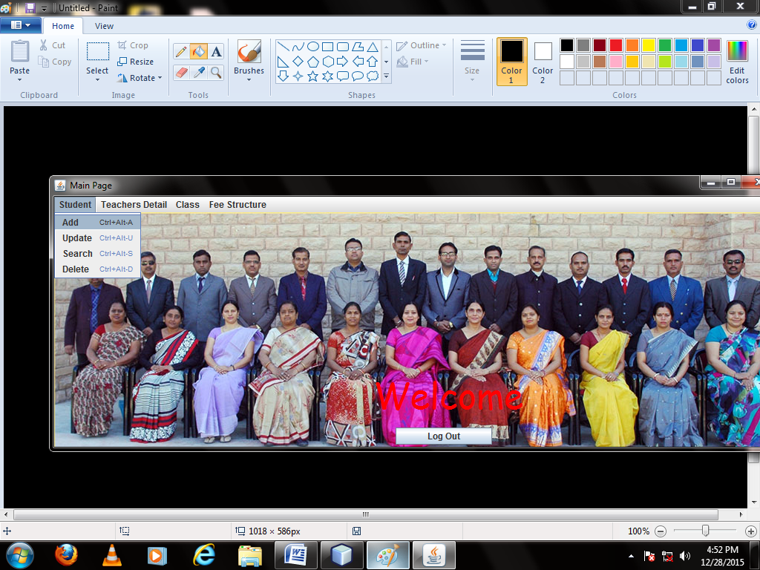

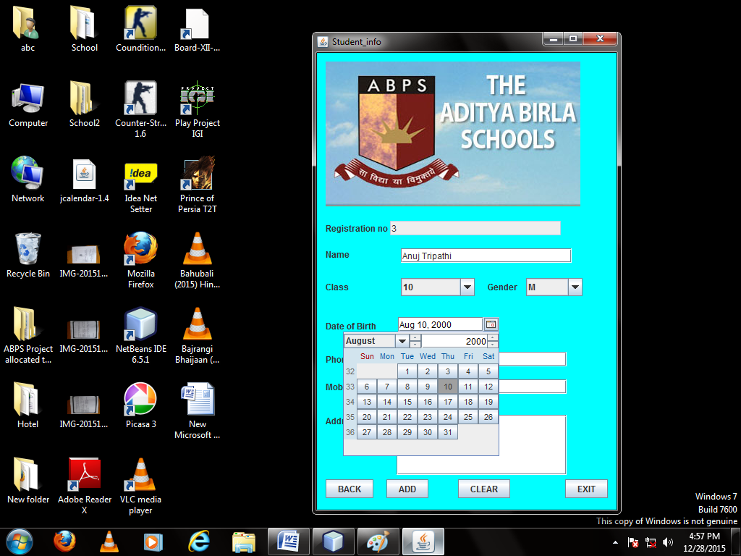

Coding:

*package school;*

*import java.awt.Color;*

*import java.text.SimpleDateFormat;*

*import java.sql.*;*

*import javax.swing.JOptionPane;*

*public class Student_info extends javax.swing.JFrame {*

public Student_info() {

initComponents();

int a;

}

*private void BackActionPerformed(java.awt.event.ActionEvent evt) {*

MainPage r=new MainPage();

r.setVisible(true);

this.dispose();

}

*private void AddActionPerformed(java.awt.event.ActionEvent evt) {*

int ans=JOptionPane.showConfirmDialog(null,"Surely Wanna insert the record");

if(ans==JOptionPane.YES_OPTION) {

try

{

Class.forName("java.sql.Driver");

Connection conn=DriverManager.getConnection("jdbc:mysql://localhost/school","root","system");

Statement stmt=conn.createStatement();

int a;

String sql2="SELECT Regn FROM student;";

ResultSet rs=stmt.executeQuery(sql2);

if(rs.last())

{

int i=rs.getInt("Regn");

a=i+1;

}

else{

a=1;

}

jTextField1.setText(""+a);

try

{

String clas = null, gender = null;

String name=jTextField2.getText();

SimpleDateFormat sdf= new SimpleDateFormat("yy-MM-dd");

String date=(String) sdf.format(jDateChooser1.getDate());

if(jComboBox1.getSelectedIndex()!=0)

clas=(String) jComboBox1.getSelectedItem();

if(jComboBox2.getSelectedIndex()!=0)

gender=(String) jComboBox2.getSelectedItem();

String phone=jTextField5.getText();

String mobile=jTextField7.getText();

String sql="INSERT INTO student VALUES("+jTextField1.getText()+",'"+name+"','"+clas+"','"+gender+"','"+date+"','"+phone+"','"+mobile+"','"

+jTextArea1.getText()+"');";

stmt.executeUpdate(sql);

String sql3="INSERT INTO fees VALUES("+jTextField1.getText()+",Null,'N','N');" ;

stmt.executeUpdate(sql3);

JOptionPane.showMessageDialog(null," record SUCCESSFULLY ADDED");

}

catch(Exception e4)

{

JOptionPane.showMessageDialog(null,"Enter All detail Correctly");

}

}

catch(Exception e) {

JOptionPane.showMessageDialog(null,"Error in connectivity");

}

}

}

*private void ClearActionPerformed(java.awt.event.ActionEvent evt) {*

jTextField1.setText("");

jTextField5.setText("");

jTextField7.setText("");

jTextArea1.setText("");

jTextField2.setText("");

jComboBox1.setSelectedIndex(0);

jComboBox2.setSelectedIndex(0);

}

*private void ExitActionPerformed(java.awt.event.ActionEvent evt) {*

System.exit(0);

}

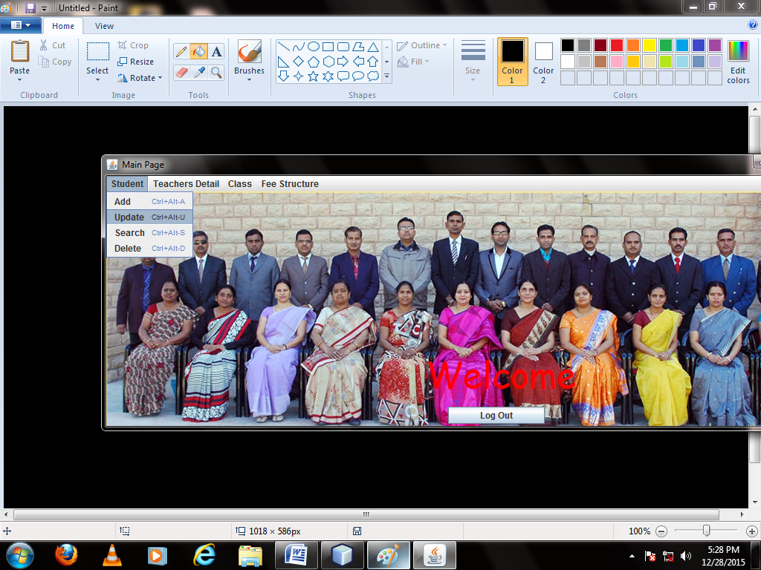

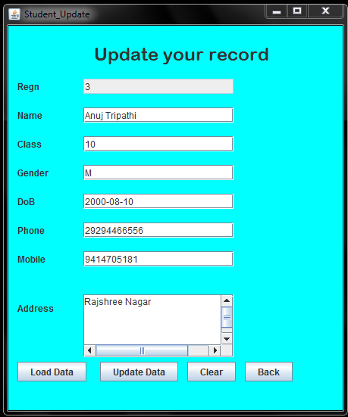

Coding:

*package school;*

*import java.awt.Color;*

*import java.sql.Connection;*

*import java.sql.DriverManager;*

*import java.sql.ResultSet;*

*import java.sql.Statement;*

*import javax.swing.JOptionPane;*

*public class Student_update extends javax.swing.JFrame {*

public Student_update() {

initComponents();

}

*private void LoadActionPerformed(java.awt.event.ActionEvent evt) {*

String regn=jTextField1.getText();

try

{

Class.forName("java.sql.Driver");

Connection con=DriverManager.getConnection("jdbc:mysql://localhost/school","root","system");

Statement stmt=con.createStatement();

String query="SELECT *FROM student WHERE Regn="+regn+";";

ResultSet rs=stmt.executeQuery(query);

while(rs.next()) {

jTextField2.setText(rs.getString(2));

jTextField3.setText(rs.getString(3));

jTextField4.setText(rs.getString(4));

jTextField5.setText(rs.getString(5));

jTextField6.setText(rs.getString(6));

jTextField7.setText(rs.getString(7));

jTextArea1.setText(rs.getString(8));

}

rs.close();

stmt.close();

con.close();

}

catch(Exception e)

{

JOptionPane.showMessageDialog(null,"error");

}

jTextField1.setEditable(false);

}

*private void ClearActionPerformed(java.awt.event.ActionEvent evt) {*

jTextField1.setText("");

jTextField2.setText("");

jTextField3.setText("");

jTextField4.setText("");

jTextField5.setText("");

jTextField6.setText("");

jTextField7.setText("");

jTextArea1.setText("");

jTextField1.setEditable(true);

}

*private void UpdateActionPerformed(java.awt.event.ActionEvent evt) {*

try{

String name=jTextField2.getText();

String date=jTextField5.getText();

String clas=jTextField3.getText();

String gender=jTextField4.getText();

String phone=jTextField6.getText();

String mobile=jTextField7.getText();

Class.forName("java.sql.Driver");

Connection con=DriverManager.getConnection("jdbc:mysql://localhost/school","root","system");

Statement stmt=con.createStatement();

String query="UPDATE student SET Name='"+name+"', Class='"+clas

+"', Gender='"+gender+"', DoB='"+date+"', Phone="+phone+

", Mobile="+mobile+ ", Address='"+jTextArea1.getText()+"' WHERE Regn="+jTextField1.getText()+";";

stmt.executeUpdate(query);

JOptionPane.showMessageDialog(null,"Data Updated");

stmt.close();

con.close();

} catch(Exception e){

JOptionPane.showMessageDialog(null,"error");

}

}

*private void BackActionPerformed(java.awt.event.ActionEvent evt) {*

MainPage r=new MainPage();

r.setVisible(true);

this.dispose();

}

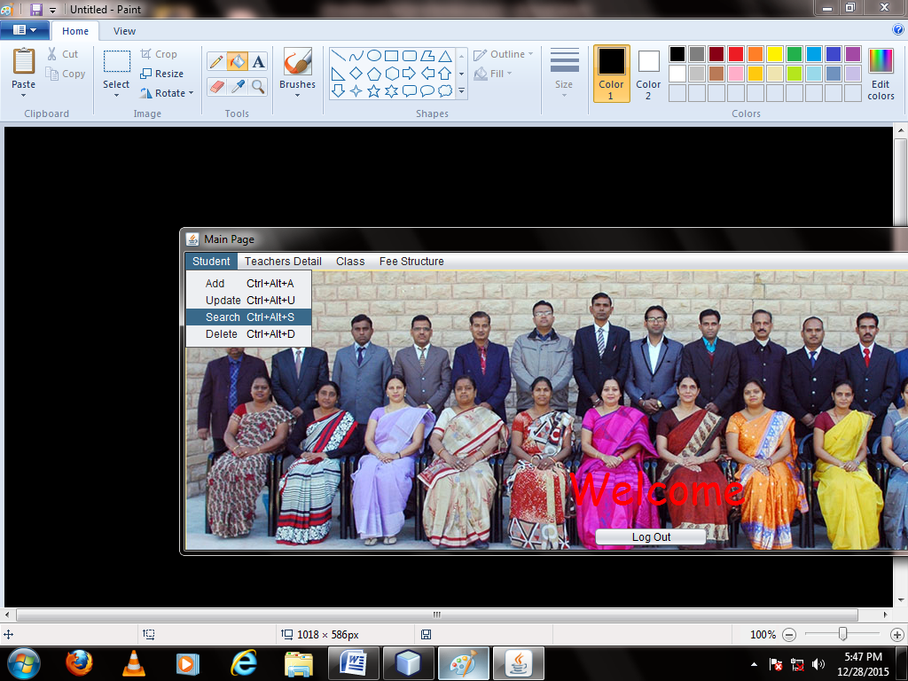

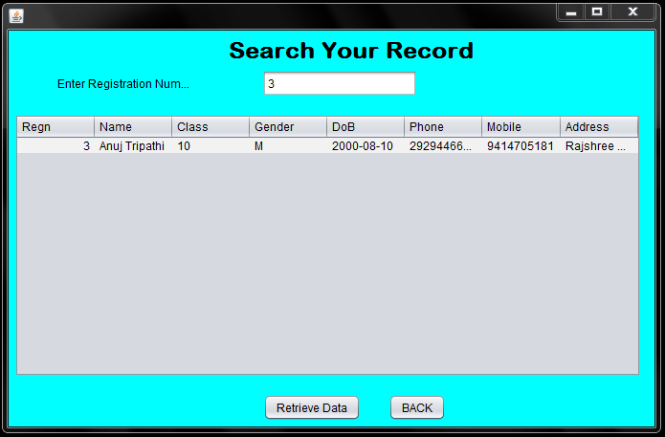

Coding:

*package school;*

*import java.awt.Color;*

*import java.sql.*;*

*import javax.swing.JOptionPane;*

*import javax.swing.table.DefaultTableModel;*

*public class student_sear extends javax.swing.JFrame {*

public student_sear() {

initComponents();

}

*private void RetrieveActionPerformed(java.awt.event.ActionEvent evt) {*

int regn= Integer.parseInt(jTextField1.getText());

DefaultTableModel model=(DefaultTableModel)jTable1.getModel();

try{

Class.forName("java.sql.Driver");

Connection con=DriverManager.getConnection("jdbc:mysql://localhost/school","root","system");

Statement stmt =con.createStatement();

String query="SELECT * FROM student WHERE Regn="+regn+";";

ResultSet rs= stmt.executeQuery(query);

while(rs.next())

{

String reg=rs.getString(1);

String name=rs.getString(2);

String Clas=rs.getString(3);

String Gender=rs.getString(4);

String Dob=rs.getString(5);

String phone=rs.getString(6);

String mobile=rs.getString(7);

String Address=rs.getString(8);

model.addRow(new Object[] {reg,name,Clas,Gender,Dob,phone,mobile,Address});

}

rs.close();

stmt.close();

con.close();

}

catch(Exception e){

JOptionPane.showMessageDialog(null,"Error");

}

}

*private void BackActionPerformed(java.awt.event.ActionEvent evt) {*

MainPage r=new MainPage();

r.setVisible(true);

this.dispose();

}

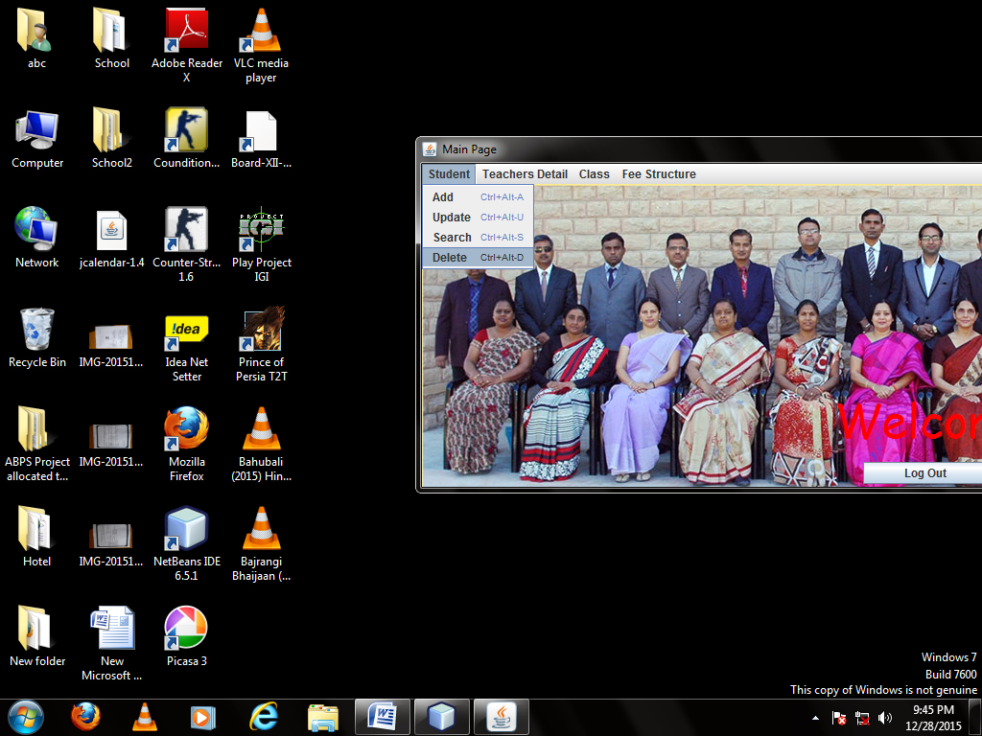

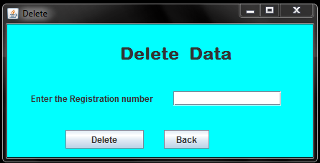

Coding:

*package school;*

*import java.awt.Color;*

*import java.sql.*;*

*import javax.swing.JOptionPane;*

*public class Student_delete extends javax.swing.JFrame {*

public Student_delete() {

initComponents();

}

*private void DeleteActionPerformed(java.awt.event.ActionEvent evt) {*

try

{

Class.forName("java.sql.Driver");

Connection con=DriverManager.getConnection("jdbc:mysql://localhost/school","root","system");

Statement stmt=con.createStatement();

String query= "DELETE FROM STUDENT WHERE Regn="+jTextField1.getText()+";";

stmt.executeUpdate(query);

JOptionPane.showMessageDialog(null,"Data Deleted.");

stmt.close();

con.close();

}

catch(Exception e)

{

JOptionPane.showMessageDialog(null,"error");

}

}

*private void BackActionPerformed(java.awt.event.ActionEvent evt) {*

MainPage r=new MainPage();

r.setVisible(true);

this.dispose();

}

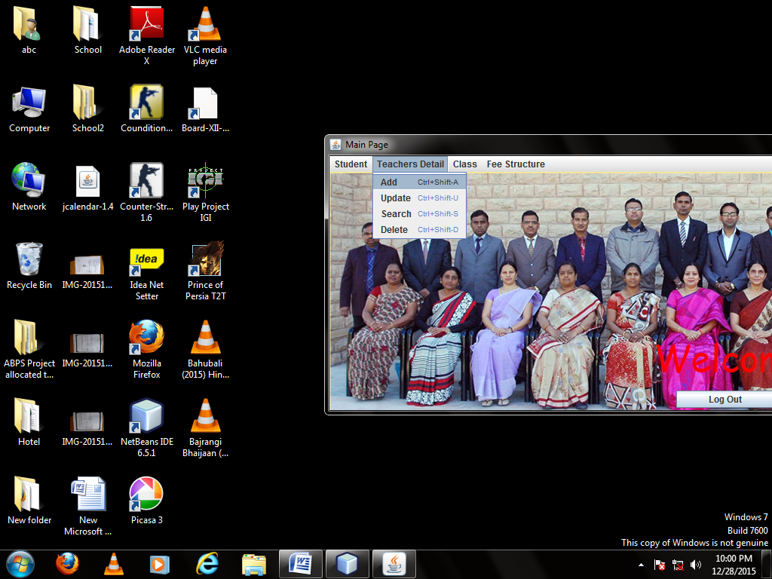

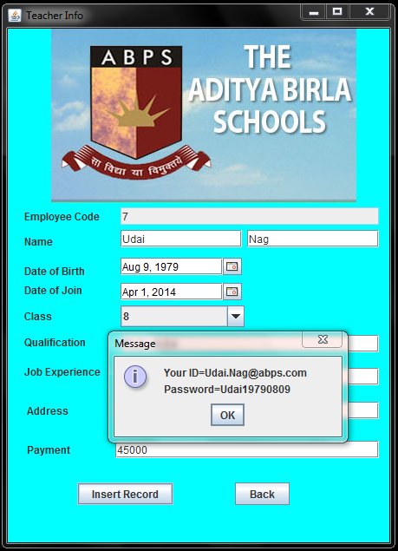

Coding:

*package school;*

*import java.awt.Color;*

*import javax.swing.JOptionPane;*

*import java.sql.*;*

*import java.text.SimpleDateFormat;*

*public class Teacher_info extends javax.swing.JFrame {*

public Teacher_info() {

initComponents();

}

*private void InsertActionPerformed(java.awt.event.ActionEvent evt) {*

sdf.format(jDateChooser1.getDate());

int ans=JOptionPane.showConfirmDialog(null,"Surely Wanna insert the record");

if(ans==JOptionPane.YES_OPTION) {

try

{

Class.forName("java.sql.Driver");

Connection conn=DriverManager.getConnection("jdbc:mysql://localhost/school","root","system");

Statement stmt=conn.createStatement();

String sql2="SELECT * FROM teacher;";

ResultSet rs=stmt.executeQuery(sql2);

int a;

if(rs.last())

{

int i=rs.getInt("Empl_code");

a=i+1;

jTextField1.setText(""+a);

}

else

{

a=1;

jTextField1.setText(""+a);

}

try

{

String name=jTextField2.getText()+" "+jTextField8.getText();

SimpleDateFormat sdf= new SimpleDateFormat("yyyy-MM-dd");

String Dob=(String) sdf.format(jDateChooser1.getDate());

String Doj=(String) sdf.format(jDateChooser2.getDate());

String Class=(String) jComboBox1.getSelectedItem();

String sql ;

sql = "INSERT INTO teacher VALUES("+jTextField1.getText()+",'"+name+"','"+Dob+"','"+Doj+"','"+Class+"','"+jTextField4.getText()+"','"+jTextField5.getText()+"','"+jTextField6.getText()+"',"+jTextField7.getText()+");";

stmt.executeUpdate(sql);

JOptionPane.showMessageDialog(null," record SUCCESSFULLY ADDED");

}

catch(Exception e4)

{

JOptionPane.showMessageDialog(null,"Enter All detail Correctly");

}

}

catch(Exception e)

{

JOptionPane.showMessageDialog(null,"Error in connectivity");

}

}

try

{

String ID=jTextField2.getText()+"."+jTextField8.getText()+"@abps.com";

SimpleDateFormat sdf= new SimpleDateFormat("yyyyMMdd");

String Dob=(String) sdf.format(jDateChooser1.getDate());

String Password=jTextField2.getText()+Dob;

JOptionPane.showMessageDialog(null,"Your ID="+ID+'\n'+"Password="+Password);

}

catch(Exception e1)

{

JOptionPane.showMessageDialog(null,"Error in connectivity");

}

jTextField1.setText("");

jTextField2.setText("");

jTextField4.setText("");

jTextField5.setText("");

jTextField6.setText("");

jTextField7.setText("");

jTextField8.setText("");

jComboBox1.setSelectedIndex(0);

jDateChooser1.setDate(null);

jDateChooser2.setDate(null);

}

private void BackActionPerformed(java.awt.event.ActionEvent evt) {

// TODO add your handling code here:

MainPage r=new MainPage();

r.setVisible(true);

this.dispose();

}

private void formComponentShown(java.awt.event.ComponentEvent evt) {

// TODO add your handling code here:

this.getContentPane().setBackground(Color.cyan);

}

private void formWindowActivated(java.awt.event.WindowEvent evt) {

// TODO add your handling code here:

try

{

Class.forName("java.sql.Driver");

Connection conn=DriverManager.getConnection("jdbc:mysql://localhost/school","root","system");

Statement stmt=conn.createStatement();

String sql="SELECT CLASS FROM teacher;";

ResultSet rs=stmt.executeQuery(sql);

while(rs.next())

{

String grade=rs.getString(1);

int i=0;

int j=jComboBox1.getItemCount();

while(i<j)

{

String Gr=(String) jComboBox1.getItemAt(i);

if(Gr.contentEquals(grade))

{

jComboBox1.removeItemAt(i);

j--;

}

i++;

}

}

}

catch(Exception E)

{

System.out.print("Error");

}

}

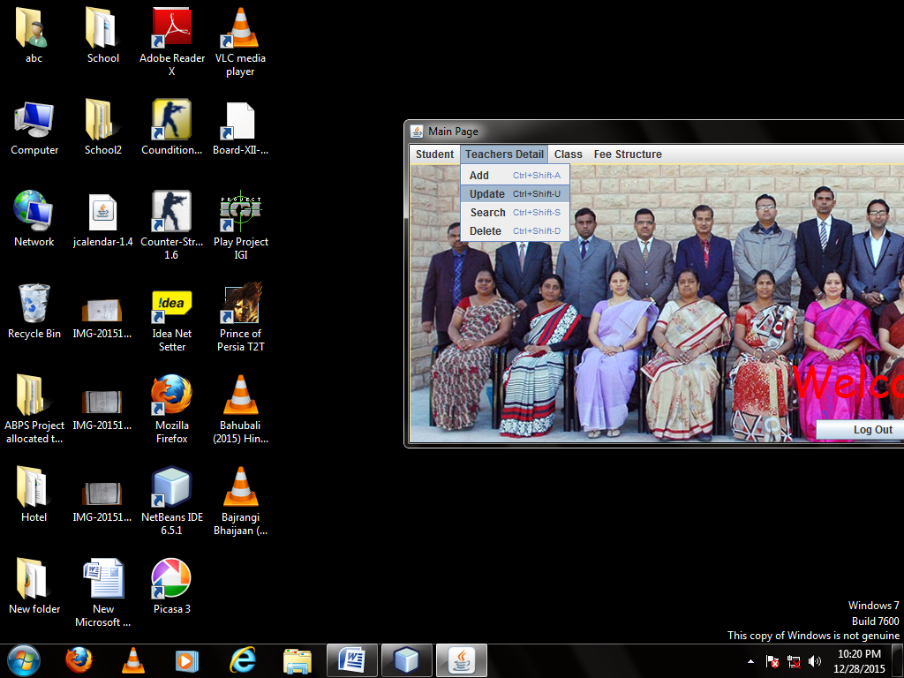

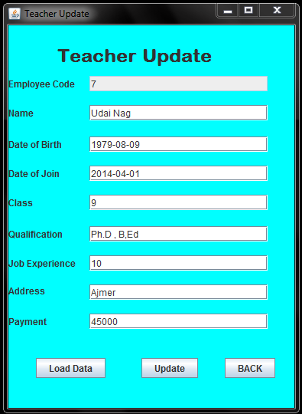

Coding:

*package school;*

*import java.awt.Color;*

*import java.sql.*;*

*import javax.swing.JOptionPane;*

*public class Teacher_update extends javax.swing.JFrame {*

public Teacher_update() {

initComponents();

}

*private void LoadActionPerformed(java.awt.event.ActionEvent evt) {*

String Empl_code=jTextField1.getText();

try

{

Class.forName("java.sql.Driver");

Connection con=DriverManager.getConnection("jdbc:mysql://localhost/school","root","system");

Statement stmt=con.createStatement();

String query="SELECT *FROM Teacher WHERE Empl_code="+Empl_code+";";

ResultSet rs=stmt.executeQuery(query);

while(rs.next())

{

jTextField2.setText(rs.getString(2));

jTextField9.setText(rs.getString(3));

jTextField10.setText(rs.getString(4));

jTextField3.setText(rs.getString(5));

jTextField4.setText(rs.getString(6));

jTextField5.setText(rs.getString(7));

jTextField6.setText(rs.getString(8));

jTextField7.setText(rs.getString(9));

}

rs.close();

stmt.close();

con.close();

}

catch(Exception e)

{

JOptionPane.showMessageDialog(null,"error");

}

jTextField1.setEditable(false);

}

*private void UpdateActionPerformed(java.awt.event.ActionEvent evt) {*

try

{

Class.forName("java.sql.Driver");

Connection con=DriverManager.getConnection("jdbc:mysql://localhost/school","root","system");

Statement stmt=con.createStatement();

String query="UPDATE teacher SET Name='"+jTextField2.getText()+"', Dob='"+jTextField9.getText()+"', DoJ='"+jTextField10.getText()+

"', Class='"+jTextField3.getText()+"', Qualification='"+jTextField4.getText()+"', Job_Exp='"+jTextField5.getText()+

"', Address='"+jTextField6.getText()+"', Payment="+jTextField7.getText()+" WHERE Empl_code="+jTextField1.getText()+" ;";

stmt.executeUpdate(query);

JOptionPane.showMessageDialog(null,"Data Updated");

stmt.close();

con.close();

}

catch(Exception e)

{

JOptionPane.showMessageDialog(null,"error");

}

}

*private void BackActionPerformed(java.awt.event.ActionEvent evt) {*

MainPage r=new MainPage();

r.setVisible(true);

this.dispose();

}

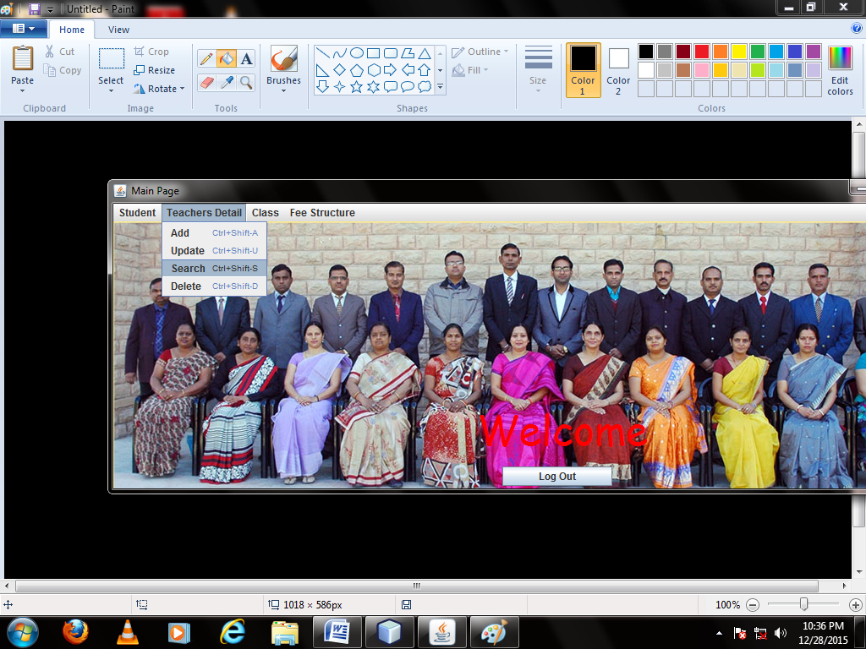

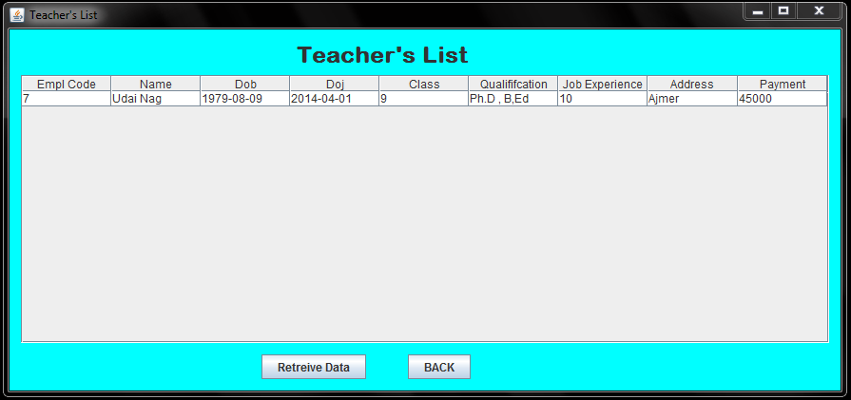

Coding:

*package school;*

*import java.awt.Color;*

*import java.sql.*;*

*import javax.swing.JOptionPane;*

*import javax.swing.table.DefaultTableModel;*

*public class teacher_search extends javax.swing.JFrame {*

/** Creates new form teacher_search */

public teacher_search() {

initComponents();

}

*private void RetreiveActionPerformed(java.awt.event.ActionEvent evt) {*

DefaultTableModel model=(DefaultTableModel)jTable1.getModel();

try{

Class.forName("java.sql.Driver");

Connection con=DriverManager.getConnection("jdbc:mysql://localhost/school","root","system");

Statement stmt =con.createStatement();

String query="SELECT * FROM teacher ;";

ResultSet rs= stmt.executeQuery(query);

while(rs.next())

{

String Empl_Code=rs.getString(1);

String name=rs.getString(2);

String Dob=rs.getString(3);

String Doj=rs.getString(4);

String Class=rs.getString(5);

String Qual=rs.getString(6);

String Job=rs.getString(7);

String Address=rs.getString(8);

String Payment=rs.getString(9);

model.addRow(new Object[] {Empl_Code,name,Dob,Doj,Class,Qual,Job,Address,Payment});

}

rs.close();

stmt.close();

con.close();

}

catch(Exception e){

JOptionPane.showMessageDialog(null,"Error");

}

}

*private void BackActionPerformed(java.awt.event.ActionEvent evt) {*

MainPage r=new MainPage();

r.setVisible(true);

this.dispose();

}

*private void formComponentShown(java.awt.event.ComponentEvent evt) {*

this.getContentPane().setBackground(Color.cyan);

}

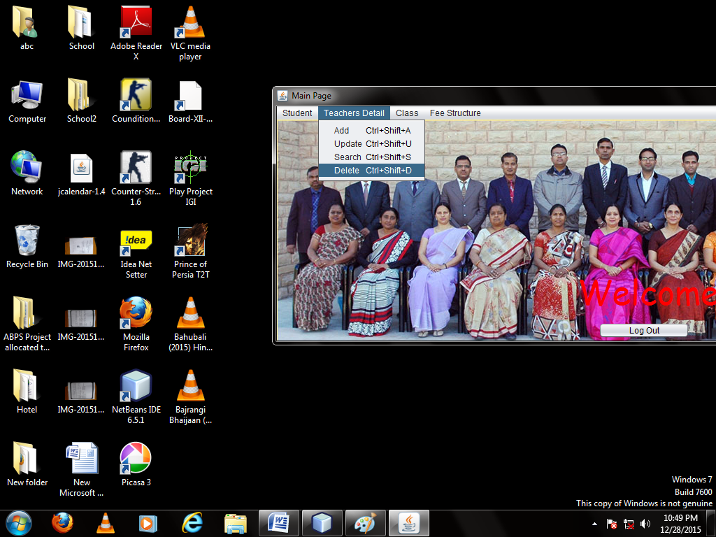

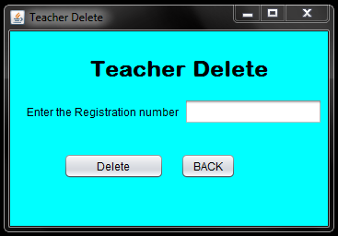

Coding:

*package school;*

*import java.awt.Color;*

*import java.sql.*;*

*import javax.swing.JOptionPane;*

*public class teacher_delete extends javax.swing.JFrame {*

public teacher_delete() {

initComponents();

}

*private void DeleteActionPerformed(java.awt.event.ActionEvent evt) {*

try{

Class.forName("java.sql.Driver");

Connection con=DriverManager.getConnection("jdbc:mysql://localhost/school","root","system");

Statement stmt=con.createStatement();

String query= "DELETE FROM teacher WHERE Empl_code="+jTextField1.getText()+";";

stmt.executeUpdate(query);

JOptionPane.showMessageDialog(null,"Data Deleted.");

stmt.close();

con.close();

}

catch(Exception e){

JOptionPane.showMessageDialog(null,"error");

}

}

*private void BackActionPerformed(java.awt.event.ActionEvent evt) {*

MainPage r=new MainPage();

r.setVisible(true);

this.dispose();

}

*private void formComponentShown(java.awt.event.ComponentEvent evt) {*

this.getContentPane().setBackground(Color.cyan);

}

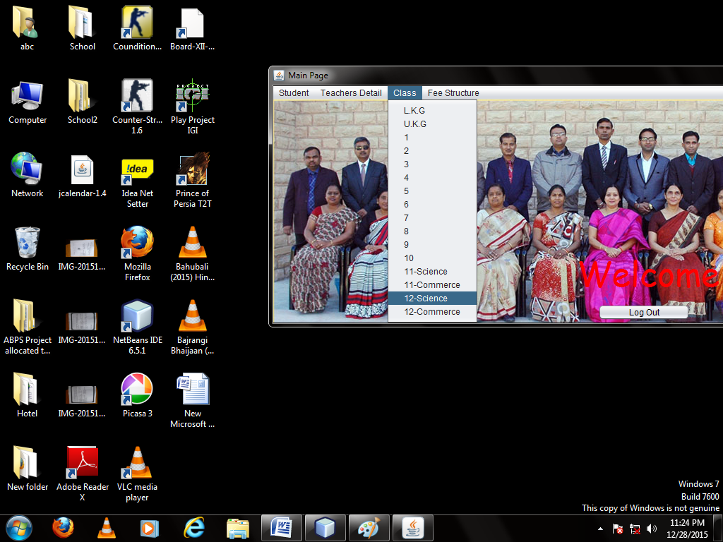

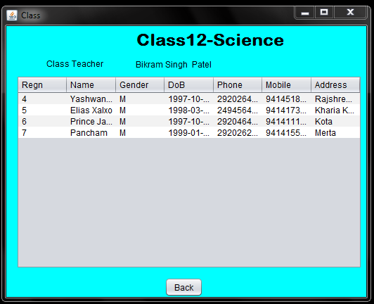

Coding:

*package school;*

*import java.awt.Color;*

*import java.sql.Connection;*

*import java.sql.DriverManager;*

*import java.sql.ResultSet;*

*import java.sql.Statement;*

*import javax.swing.table.DefaultTableModel;*

*public class NewJFrame extends javax.swing.JFrame {*

String Grade;

public NewJFrame() {

initComponents();

}

*private void formWindowActivated(java.awt.event.WindowEvent evt) {*

jLabel2.setText("Class"+Grade);

DefaultTableModel model=(DefaultTableModel)jTable1.getModel();

try{

Class.forName("java.sql.Driver");

Connection con=DriverManager.getConnection("jdbc:mysql://localhost/school","root","system");

Statement stmt =con.createStatement();

String query="SELECT * FROM student WHERE Class='"+Grade+"';";

ResultSet rs= stmt.executeQuery(query);

while(rs.next())

{

String reg=rs.getString(1);

String name=rs.getString(2);

String Gender=rs.getString(4);

String Dob=rs.getString(5);

String phone=rs.getString(6);

String mobile=rs.getString(7);

String Address=rs.getString(8);

model.addRow(new Object[] {reg,name,Gender,Dob,phone,mobile,Address});

}

String query1="SELECT Name FROM teacher WHERE Class='"+Grade+"';";

ResultSet rs2=stmt.executeQuery(query1);

while(rs2.next())

{

jLabel3.setText(rs2.getString(1));

}

rs.close();

stmt.close();

con.close();

}

catch(Exception e)

{

System.out.print("Error");

}

}

*private void BackActionPerformed(java.awt.event.ActionEvent evt) {*

MainPage r=new MainPage();

r.setVisible(true);

this.dispose();

}

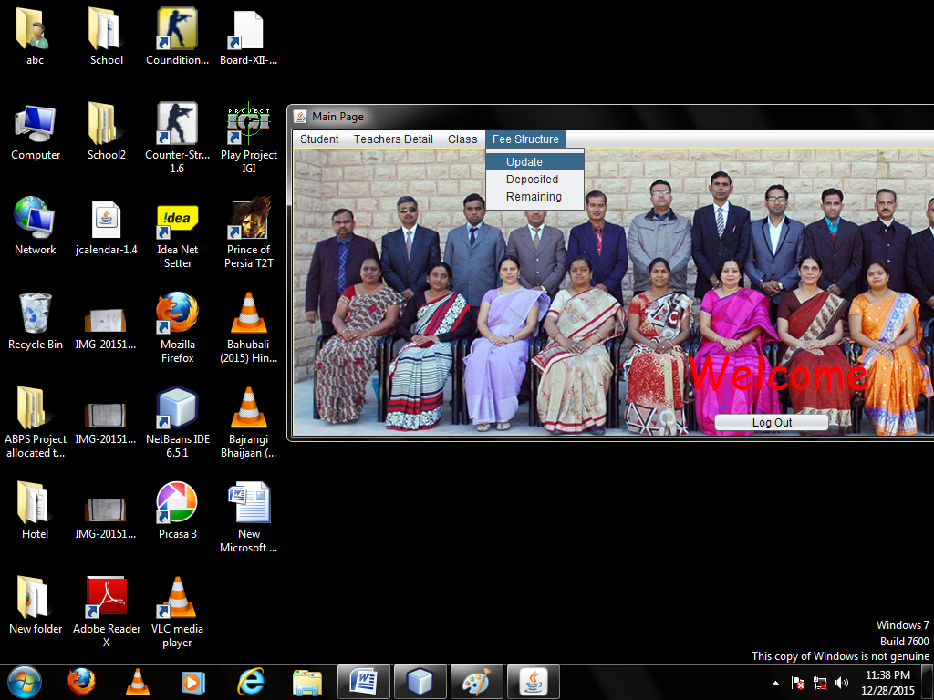

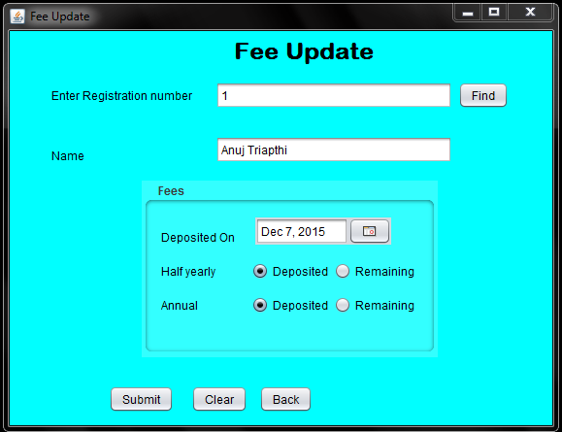

Coding:

*package school;*

*import java.awt.Color;*

*import java.sql.Connection;*

*import java.sql.DriverManager;*

*import java.sql.ResultSet;*

*import java.sql.Statement;*

*import java.text.SimpleDateFormat;*

*import javax.swing.JOptionPane;*

*public class Deposited extends javax.swing.JFrame {*

*Connection con=null;*

*Statement stmt=null;*

public Deposited() {

initComponents();

}

*private void jButton1ActionPerformed(java.awt.event.ActionEvent evt) {*

try{

Class.forName("java.sql.Driver");

con=DriverManager.getConnection("jdbc:mysql://localhost/school","root","system");

stmt =con.createStatement();

String query="SELECT Name FROM student WHERE Regn="+jTextField1.getText()+";";

ResultSet rs= stmt.executeQuery(query);

while(rs.next()){

jTextField2.setText(rs.getString(1));

}

String query2="SELECT * FROM Fees WHERE Regn="+jTextField1.getText()+";";

ResultSet rs2= stmt.executeQuery(query2);

while(rs2.next()){

jDateChooser1.setDate(rs2.getDate(2));

if(rs2.getString(3).equals("N")) {

jRadioButton2.setSelected(true);

}

if(rs2.getString(3).equals("Y")) {

jRadioButton1.setSelected(true);

}

if(rs2.getString(4).equals("N")) {

jRadioButton4.setSelected(true);

}

if(rs2.getString(4).equals("Y")) {

jRadioButton3.setSelected(true);

}

}

rs.close();

stmt.close();

con.close();

}

catch(Exception e){

JOptionPane.showMessageDialog(null,"Error");

}

jTextField1.setEditable(false);

}

*private void jButton2ActionPerformed(java.awt.event.ActionEvent evt) {*

try{ String Half = null,Annual = null;

if (jRadioButton1.isSelected()==true)

{

Half="Y";

}

if (jRadioButton2.isSelected()==true)

{

Half="N";

}

if (jRadioButton3.isSelected()==true)

{

Annual="Y";

}

if (jRadioButton4.isSelected()==true)

{

Annual="N";

}

SimpleDateFormat sdf= new SimpleDateFormat("yyyy-MM-dd");

String Date=(String) sdf.format(jDateChooser1.getDate());

Class.forName("java.sql.Driver");

con=DriverManager.getConnection("jdbc:mysql://localhost/school","root","system");

stmt =con.createStatement();

String query="Update Fees Set Date='"+Date+"', Half='"+Half+"', Annual='"+Annual+""

+ "' where Regn="+jTextField1.getText()+";";

stmt.executeUpdate(query);

stmt.close();

con.close();

JOptionPane.showMessageDialog(null,"Data Updated");

}

catch(Exception e){

JOptionPane.showMessageDialog(null,"Error");

}

}

*private void ClearActionPerformed(java.awt.event.ActionEvent evt) {*

jTextField1.setText("");

jTextField2.setText("");

jDateChooser1.setDate(null);

jTextField1.setEditable(true);

jRadioButton3.setSelected(false);

jRadioButton1.setSelected(false);

jRadioButton2.setSelected(false);

jRadioButton4.setSelected(false);

}

*private void jButton4ActionPerformed(java.awt.event.ActionEvent evt) {*

MainPage r=new MainPage();

r.setVisible(true);

this.dispose();

}

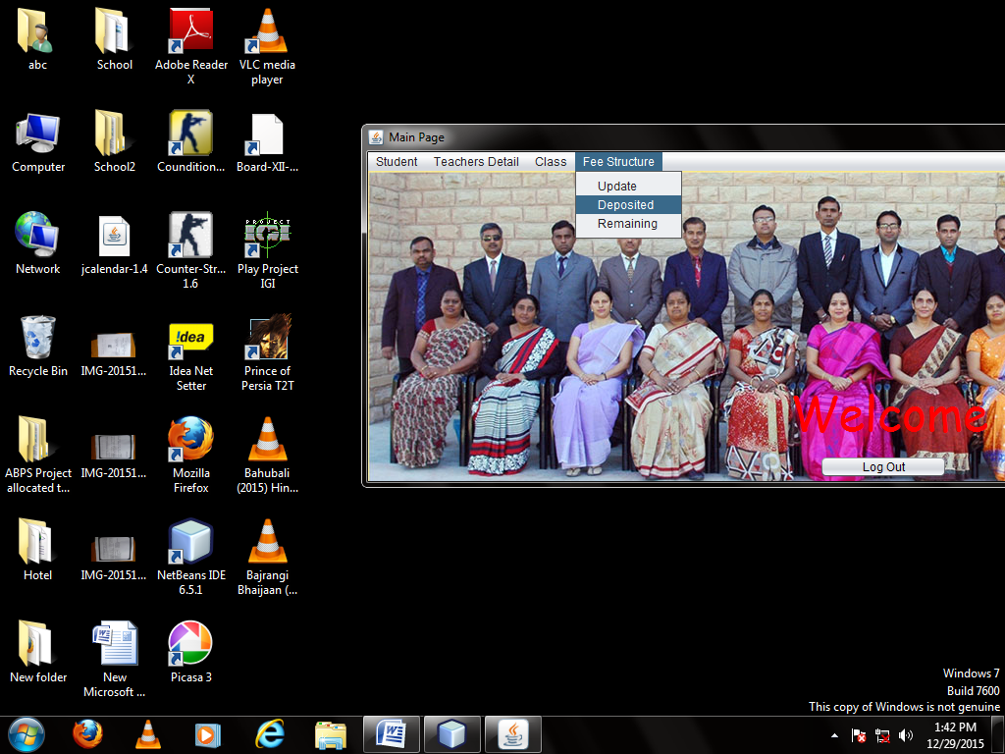

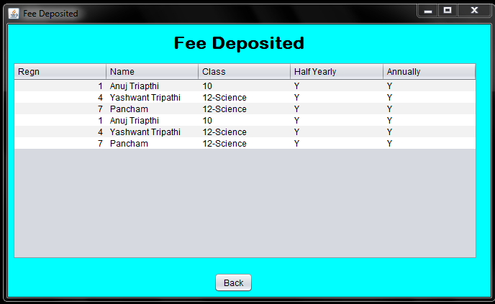

Coding:

*package school;*

*import java.awt.Color;*

*import java.sql.Connection;*

*import java.sql.DriverManager;*

*import java.sql.ResultSet;*

*import java.sql.Statement;*

*import javax.swing.JOptionPane;*

*import javax.swing.table.DefaultTableModel;*

*public class feedepo extends javax.swing.JFrame {*

public feedepo() {

initComponents();

}

*private void formWindowActivated(java.awt.event.WindowEvent evt) {*

DefaultTableModel model=(DefaultTableModel)jTable1.getModel();try{

Class.forName("java.sql.Driver");

Connection con=DriverManager.getConnection("jdbc:mysql://localhost/school","root","system");

Statement stmt =con.createStatement();

String query="select Student.Regn,Name,Class,Half,Annual from Student, fees Where Student.Regn=Fees.Regn and Half='Y' and Annual='Y'";

ResultSet rs= stmt.executeQuery(query);

while(rs.next())

{

String reg=rs.getString(1);

String name=rs.getString(2);

String Clas=rs.getString(3);

String Half=rs.getString(4);

String Annual=rs.getString(5);

model.addRow(new Object[] {reg,name,Clas,Half,Annual});

}

rs.close();

stmt.close();

con.close();

}

catch(Exception e){

JOptionPane.showMessageDialog(null,"Error");

}

}

*private void BackActionPerformed(java.awt.event.ActionEvent evt) {*

MainPage r=new MainPage();

r.setVisible(true);

this.dispose();

}

*private void formComponentShown(java.awt.event.ComponentEvent evt) {*

this.getContentPane().setBackground(Color.cyan);

}

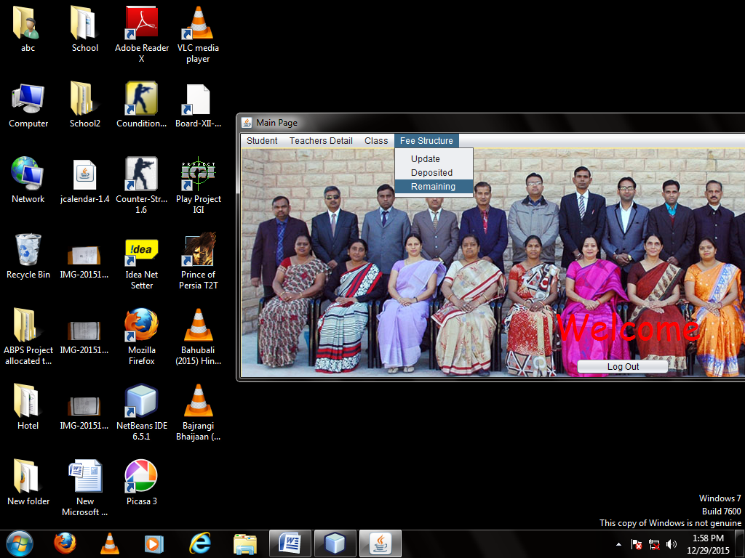

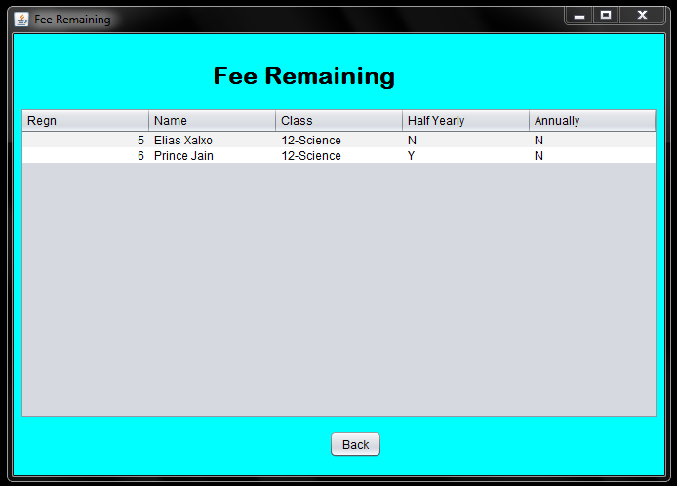

Coding:

*package school;*

*import java.awt.Color;*

*import java.sql.Connection;*

*import java.sql.DriverManager;*

*import java.sql.ResultSet;*

*import java.sql.Statement;*

*import javax.swing.JOptionPane;*

*import javax.swing.table.DefaultTableModel;*

*public class feeremain extends javax.swing.JFrame {*

public feeremain() {

initComponents();

}

*private void formWindowActivated(java.awt.event.WindowEvent evt) {*

DefaultTableModel model=(DefaultTableModel)jTable1.getModel();

try{

Class.forName("java.sql.Driver");

Connection con=DriverManager.getConnection("jdbc:mysql://localhost/school","root","system");

Statement stmt =con.createStatement();

String query="SELECT Student.Regn,Name,Class,Half,Annual FROM Student,Fees WHERE Student.Regn=Fees.Regn and (Half='N' Or Annual='N');";

ResultSet rs= stmt.executeQuery(query);

while(rs.next())

{

String reg=rs.getString(1);

String name=rs.getString(2);

String Clas=rs.getString(3);

String Half=rs.getString(4);

String Annual=rs.getString(5);

model.addRow(new Object[] {reg,name,Clas,Half,Annual});

}

rs.close();

stmt.close();

con.close();

}

catch(Exception e){

JOptionPane.showMessageDialog(null,"Error");

}

}

*private void BackActionPerformed(java.awt.event.ActionEvent evt) {*

MainPage r=new MainPage();

r.setVisible(true);

this.dispose();

}

*private void formComponentShown(java.awt.event.ComponentEvent evt) {*

this.getContentPane().setBackground(Color.cyan);

}

* Informatics Practices Class 12 Sumita Arora
* NCERT Text Book
* Together With Informatics Practices